

Data Analysis with Power BI & KNIME
(ETSEDA115)

MCA (AI & ML)
Sem 1
2501940078

Assignment 3

Submitted by Submitted to
Sujal chugh Mr. Mohammad Aijaz

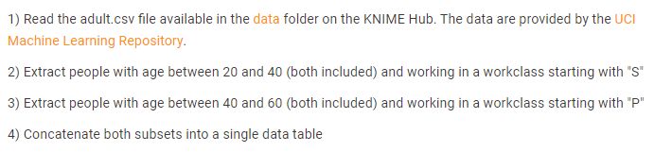

- Read the adult.csv file
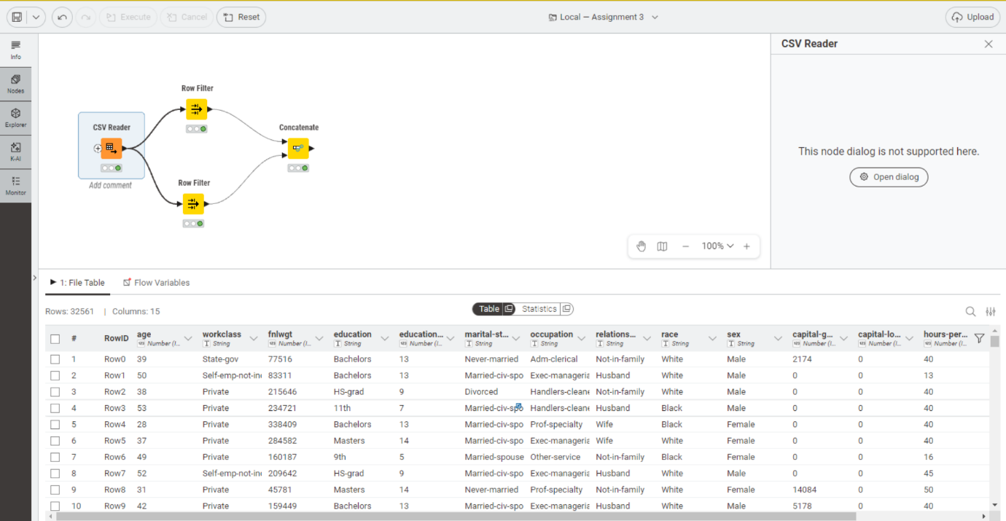

- Extract people with age between 20 and 40 (both included) and working in a work class starting with “S”
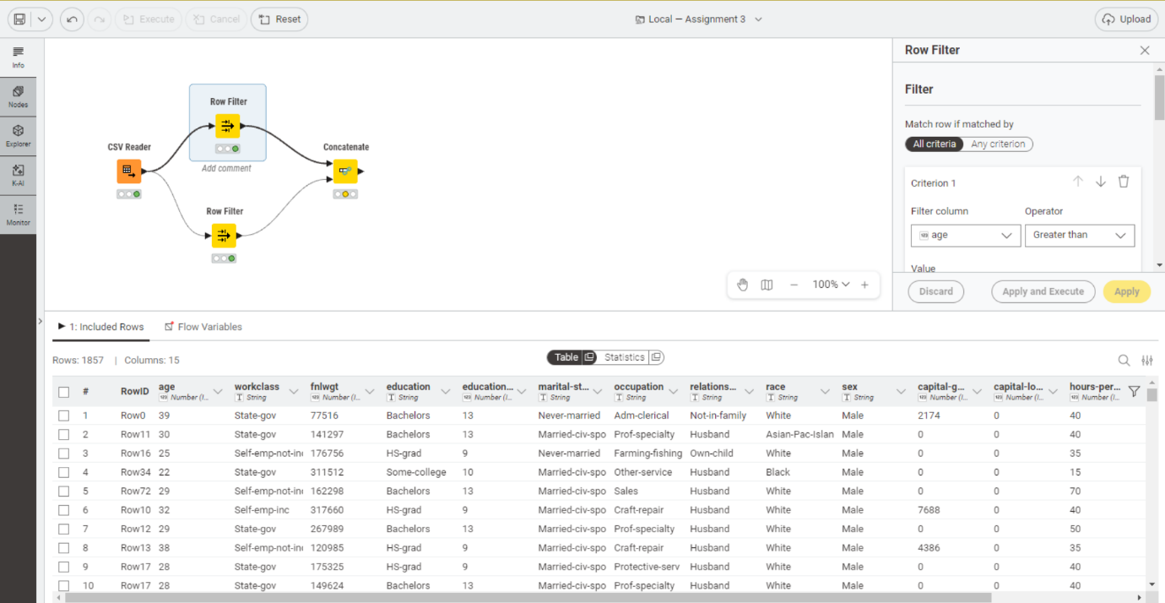
- Extract People with age between 40 and 60 (both included) and working in a work class starting with “P”
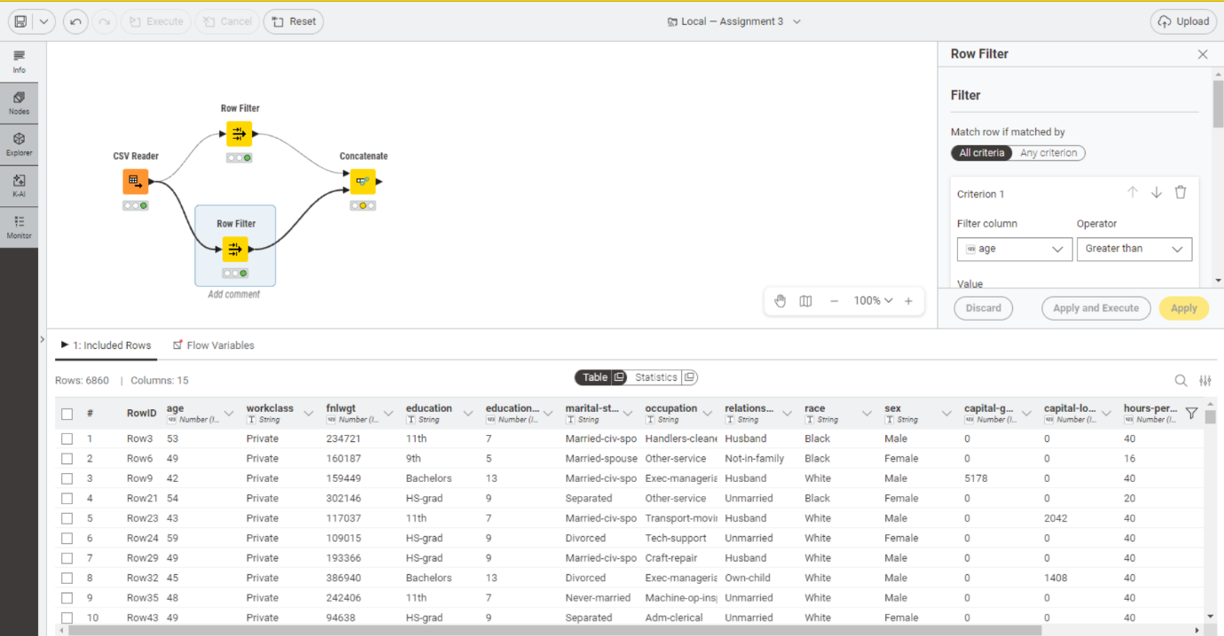

- Concatenate both subsets into a single data
